Q1.

1. We need to enter the following Script.

select (Salary), (EName)from employee

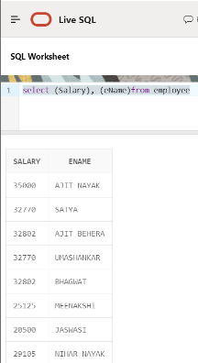

B. select ename from employee where ename like'A%'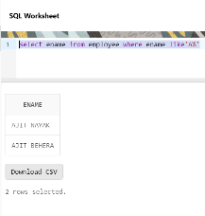

C. select (eName) from employee where bdate>16

Ans.

select * from employee

where bdate <'25-APR-55';

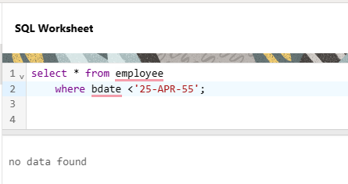

there is no date less then 25-APR-55

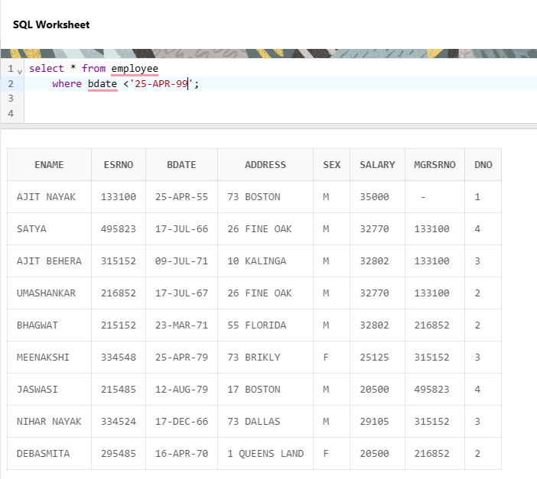

where as less then 25-APR-55 is present.

d. select (eName) from employee where sex= ‘f’

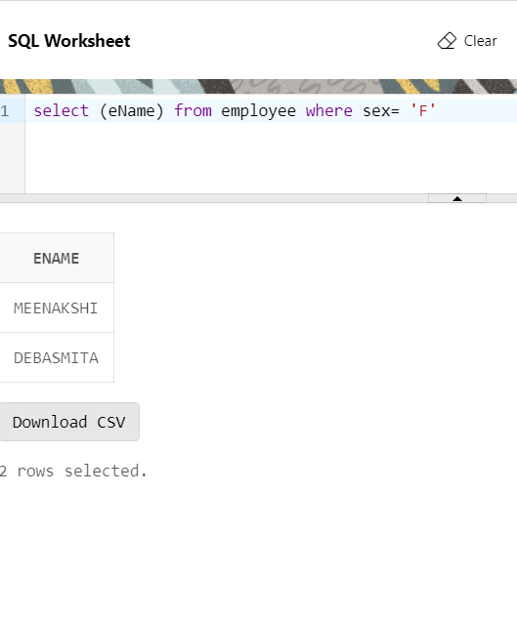

e.

select (eName) from employee where salary=max

Ans.

SELECT ename, salary, MAX(salary) OVER (PARTITION BY ename) AS first_name

FROM Employee

WHERE salary = (SELECT MAX(salary) FROM Employee);

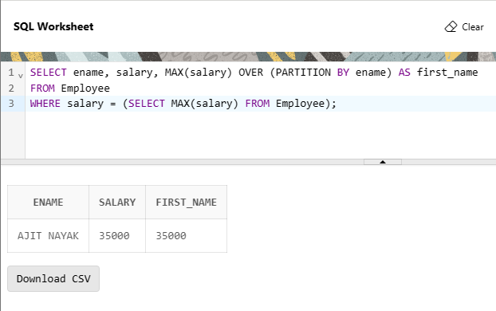

Q2.

A) Display employee name, address, department no and department name.

Ans.

SELECT E.ENAME, E.ADDRESS, D.DNAME, D.DNUMBER from EMPLOYEE E

FULL JOIN DEPARTMENT D

ON E.MGRSRNO = D.MGRSRNO

GROUP BY E.ENAME, E.ADDRESS, D.DNAME, D.DNUMBER;

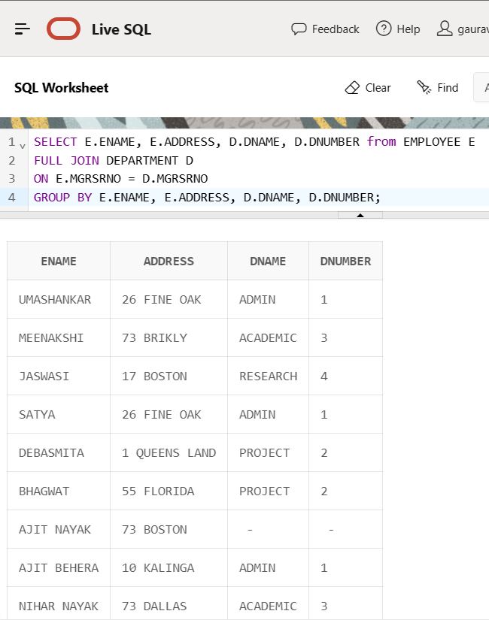

Working note-

Table names-

EMPLOYEE- ENAME, ESRNO, BDATE, ADDRESS, SEX, SALARY, MGRSRNO, DNO

DEPARTMENT - DNAME,DNUMBER, MGRSRNO, MGRSTARTD

DEPT_LOCATIONS - DLOCATION, DNUMBER

PROJECT- PNAME, PNUMBER, PLOCATION, DNUM

WORKS_ON - ESRNO, PNO NUMBER, HOURS

select * from EMPLOYEE;

select * from DEPARTMENT;

select * from DEPT_LOCATIONS;

select * from PROJECT;

select * from WORKS_ON ;

Q2.B

Display all the employees who are not in ACADEMIC department

Ans.

SELECT * FROM DEPARTMENT

WHERE DNAME='ACADEMIC';

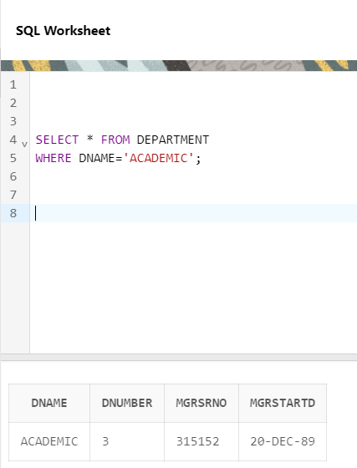

Q2.C Display SATYA’S project location.

SELECT ADDRESS, ENAME

FROM Employee

WHERE ENAME='SATYA'

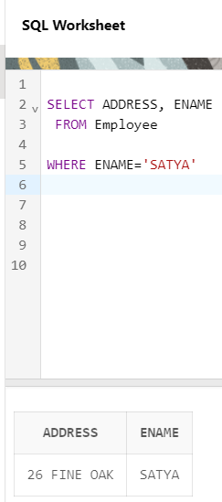

FIRST FROM THEN WHERE CLAUSE USED.

Q2.d Find the total working hours of each female employee.

Q2.E Display the details of the people whose projects are located at SOUTHAFRICA.

Ans.

SELECT * FROM Employee

WHERE address='southafrica';

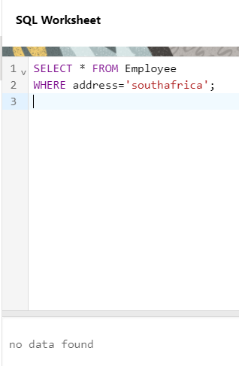

No one is from south africa.